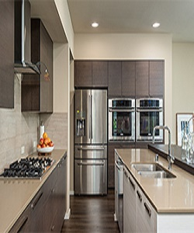

Modern Poliform Kitchen cabinets

$187.99

Availability: In stock

Description

Tremendous tall Kitchen Cabinets on Walnut Omega. Modern European yellow and white curved kitchen cabinets. The smooth-surfaced doors are custom made to your kitchen project, available in the range of sheen levels.